**Mandatory hands-on**

**Microservices with Spring Boot 3 and Spring Cloud**

**2. Microservices with API gateway**

**Exercise: Creating Microservices for account and loan**

**Account Microservice**

**Code:**

**AccountController.java**

package com.cognizant.account;

import org.springframework.web.bind.annotation.*;

import java.util.Map;

import java.util.HashMap;

@RestController

public class AccountController {

@GetMapping("/accounts/{number}")

public Map<String, Object> getAccountDetails(@PathVariable String number) {

Map<String, Object> response = new HashMap<>();

response.put("number", number);

response.put("type", "savings");

response.put("balance", 23000);

return response;

}

}

**AccountApplication.java**

package com.cognizant.account;

import org.springframework.boot.SpringApplication;

import org.springframework.boot.autoconfigure.SpringBootApplication;

@SpringBootApplication

public class AccountApplication {

public static void main(String[] args) {

SpringApplication.run(AccountApplication.class, args);

}

}

**pom.xml**

<?xml version=*"1.0"* encoding=*"UTF-8"*?>

<project xmlns=*"http://maven.apache.org/POM/4.0.0"* xmlns:xsi=*"http://www.w3.org/2001/XMLSchema-instance"*

xsi:schemaLocation=*"http://maven.apache.org/POM/4.0.0 https://maven.apache.org/xsd/maven-4.0.0.xsd"*>

<modelVersion>4.0.0</modelVersion>

<parent>

<groupId>org.springframework.boot</groupId>

<artifactId>spring-boot-starter-parent</artifactId>

<version>3.5.3</version>

<relativePath/> <!-- lookup parent from repository -->

</parent>

<groupId>com.cognizant</groupId>

<artifactId>account</artifactId>

<version>0.0.1-SNAPSHOT</version>

<name>account</name>

<description>Demo project for Spring Boot</description>

<url/>

<licenses>

<license/>

</licenses>

<developers>

<developer/>

</developers>

<scm>

<connection/>

<developerConnection/>

<tag/>

<url/>

</scm>

<properties>

<java.version>17</java.version>

</properties>

<dependencies>

<dependency>

<groupId>org.springframework.boot</groupId>

<artifactId>spring-boot-starter-web</artifactId>

</dependency>

<dependency>

<groupId>org.springframework.boot</groupId>

<artifactId>spring-boot-devtools</artifactId>

<scope>runtime</scope>

<optional>true</optional>

</dependency>

<dependency>

<groupId>org.springframework.boot</groupId>

<artifactId>spring-boot-starter-test</artifactId>

<scope>test</scope>

</dependency>

</dependencies>

<build>

<plugins>

<plugin>

<groupId>org.springframework.boot</groupId>

<artifactId>spring-boot-maven-plugin</artifactId>

</plugin>

</plugins>

</build>

</project>

**Output:**

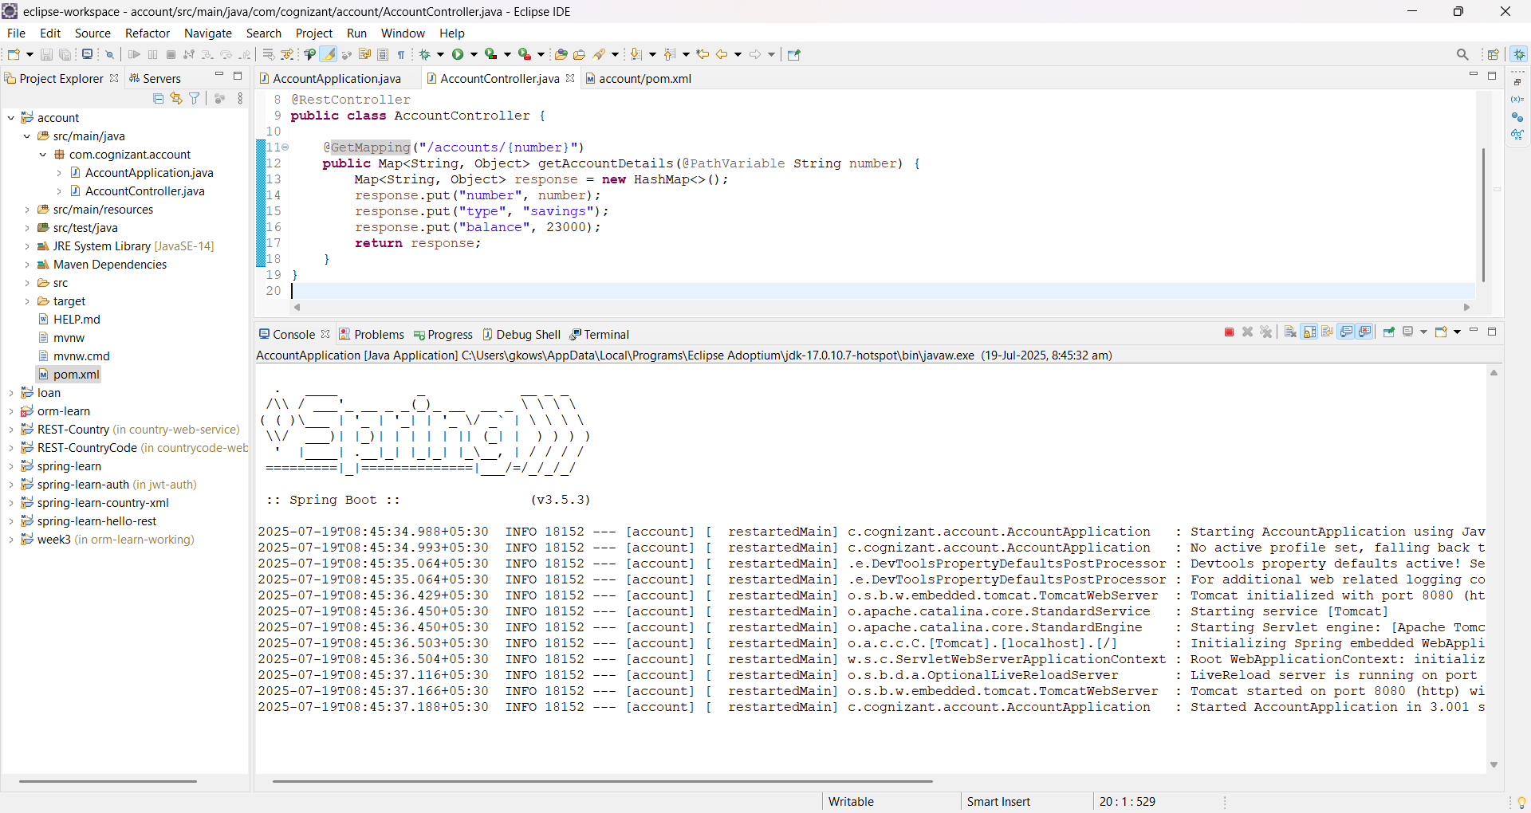

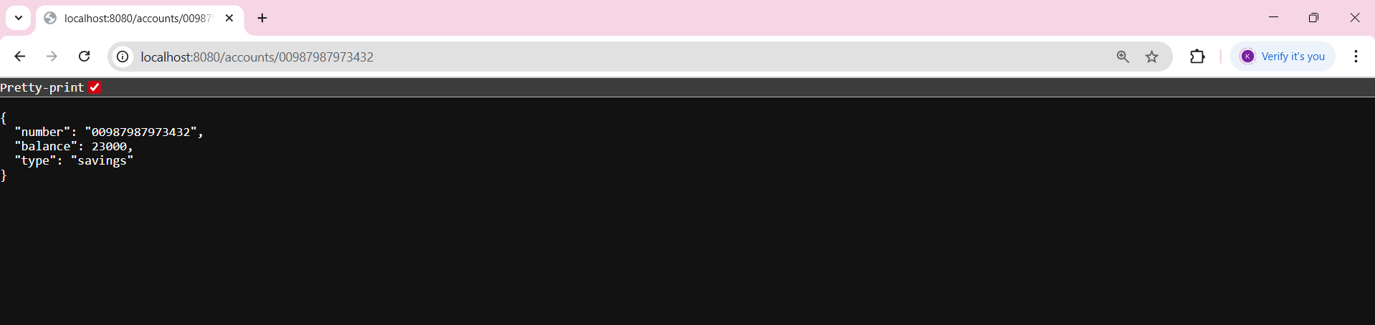

**Loan Microservice**

**Code:**

**LoanApplication.java**

package com.cognizant.loan;

import org.springframework.boot.SpringApplication;

import org.springframework.boot.autoconfigure.SpringBootApplication;

@SpringBootApplication

public class LoanApplication {

public static void main(String[] args) {

SpringApplication.run(LoanApplication.class, args);

}

}

**LoanController.java**

package com.cognizant.loan;

import org.springframework.web.bind.annotation.*;

import java.util.Map;

import java.util.HashMap;

@RestController

public class LoanController {

@GetMapping("/loans/{number}")

public Map<String, Object> getLoanDetails(@PathVariable String number) {

Map<String, Object> response = new HashMap<>();

response.put("number", number);

response.put("type", "car");

response.put("loan", 400000);

response.put("emi", 3258);

response.put("tenure", 18);

return response;

}

}

**pom.xml**

<?xml version=*"1.0"* encoding=*"UTF-8"*?>

<project xmlns=*"http://maven.apache.org/POM/4.0.0"* xmlns:xsi=*"http://www.w3.org/2001/XMLSchema-instance"*

xsi:schemaLocation=*"http://maven.apache.org/POM/4.0.0 https://maven.apache.org/xsd/maven-4.0.0.xsd"*>

<modelVersion>4.0.0</modelVersion>

<parent>

<groupId>org.springframework.boot</groupId>

<artifactId>spring-boot-starter-parent</artifactId>

<version>3.5.3</version>

<relativePath/> <!-- lookup parent from repository -->

</parent>

<groupId>com.cognizant</groupId>

<artifactId>loan</artifactId>

<version>0.0.1-SNAPSHOT</version>

<name>loan</name>

<description>Demo project for Spring Boot</description>

<url/>

<licenses>

<license/>

</licenses>

<developers>

<developer/>

</developers>

<scm>

<connection/>

<developerConnection/>

<tag/>

<url/>

</scm>

<properties>

<java.version>17</java.version>

</properties>

<dependencies>

<dependency>

<groupId>org.springframework.boot</groupId>

<artifactId>spring-boot-starter-web</artifactId>

</dependency>

<dependency>

<groupId>org.springframework.boot</groupId>

<artifactId>spring-boot-devtools</artifactId>

<scope>runtime</scope>

<optional>true</optional>

</dependency>

<dependency>

<groupId>org.springframework.boot</groupId>

<artifactId>spring-boot-starter-test</artifactId>

<scope>test</scope>

</dependency>

</dependencies>

<build>

<plugins>

<plugin>

<groupId>org.springframework.boot</groupId>

<artifactId>spring-boot-maven-plugin</artifactId>

</plugin>

</plugins>

</build>

</project>

**Output:**

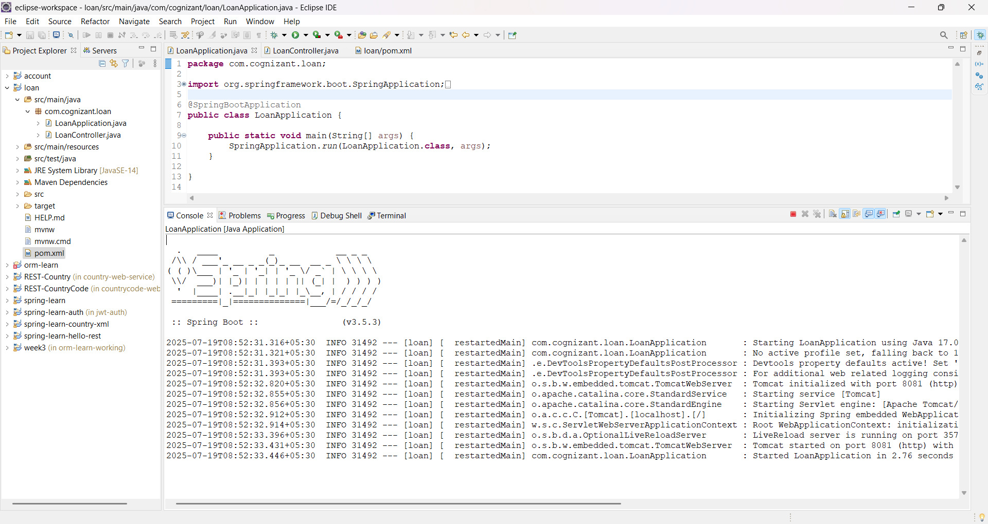

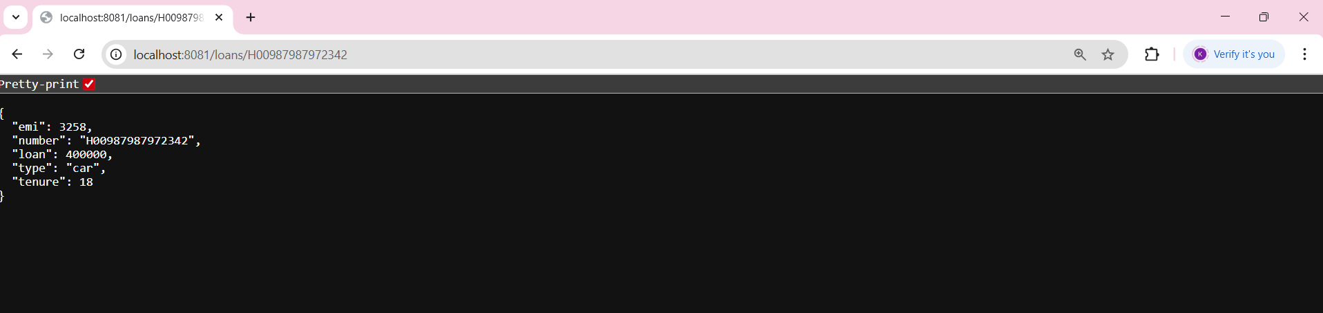

**Additional Hands-On**

**Exercise: Create Eureka Discovery Server and register microservices**

**Output:**

**Eureka Discovery Server**

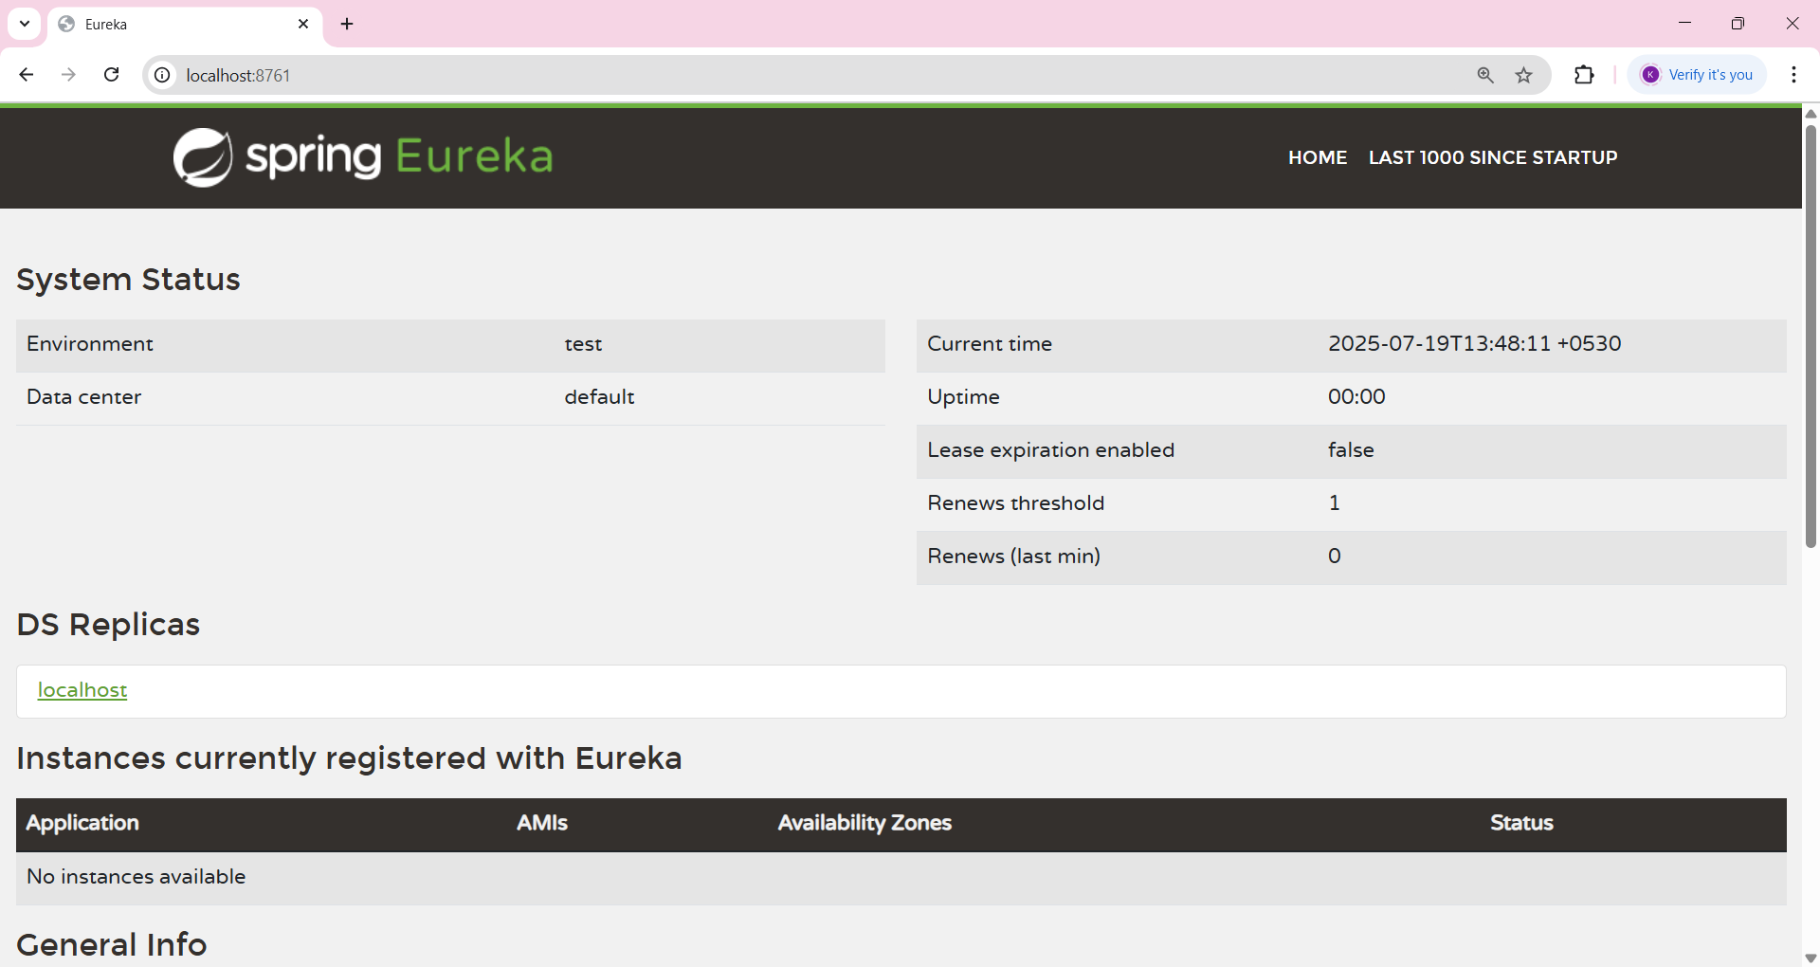

**Account-Service**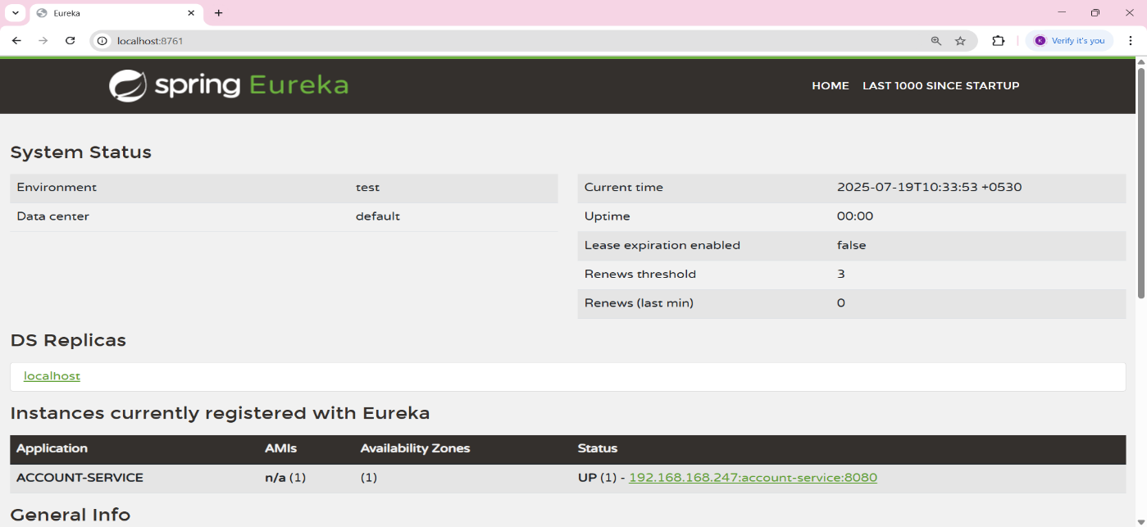

**Loan-Service**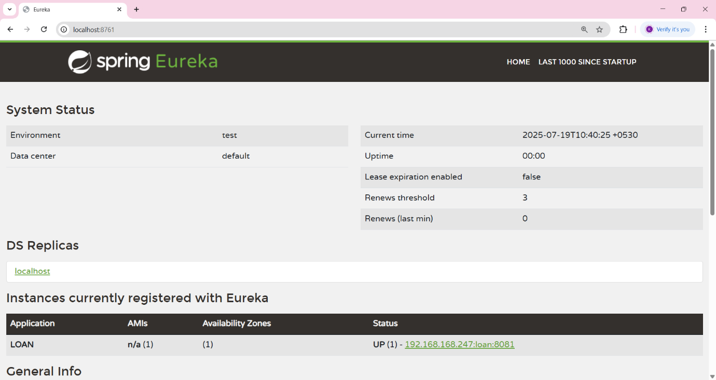

**Greet-Service**

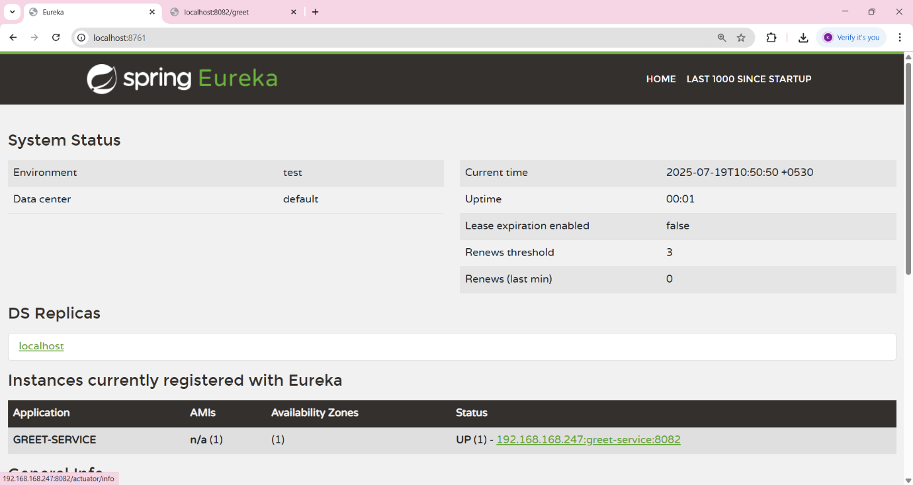

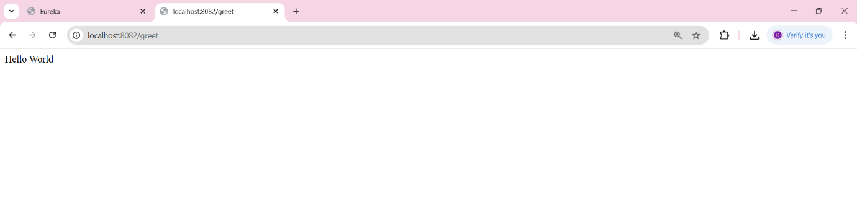

**API-Gateway**